SENTIMENT ANALYSIS

INTRODUCTION:

Sentiment analysis, also known as opinion mining, is a powerful natural language processing (NLP) technique that aims to understand and quantify the emotional tone or sentiment expressed in text data.

It plays a crucial role in various domains, including marketing, customer feedback analysis, social media monitoring, and even in academic research. In your project, you will explore the fascinating world of sentiment analysis and its applications.

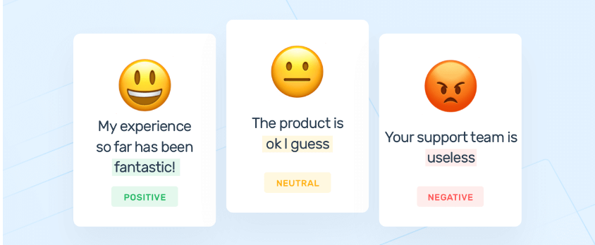

PURPOSE AND OBJECTIVE:

PURPOSE:

The purpose of a sentiment analysis project is to leverage natural language processing (NLP) techniques to gain insights into the sentiments, opinions, and emotions expressed in textual data. Sentiment analysis helps organizations and individuals make data-driven decisions, improve products and services, enhance customer satisfaction, and manage online reputation. The primary purpose of a sentiment analysis project is to extract meaningful information from text data by quantifying sentiments, and it can serve various specific objectives depending on the context.

OBJECTIVE:

* **Understanding Public Opinion**
* **Customer Feedback Analysis**
* **Market Research**
* **Reputation Management**
* **Political and Social Analysis**
* **Product and Service Improvement**

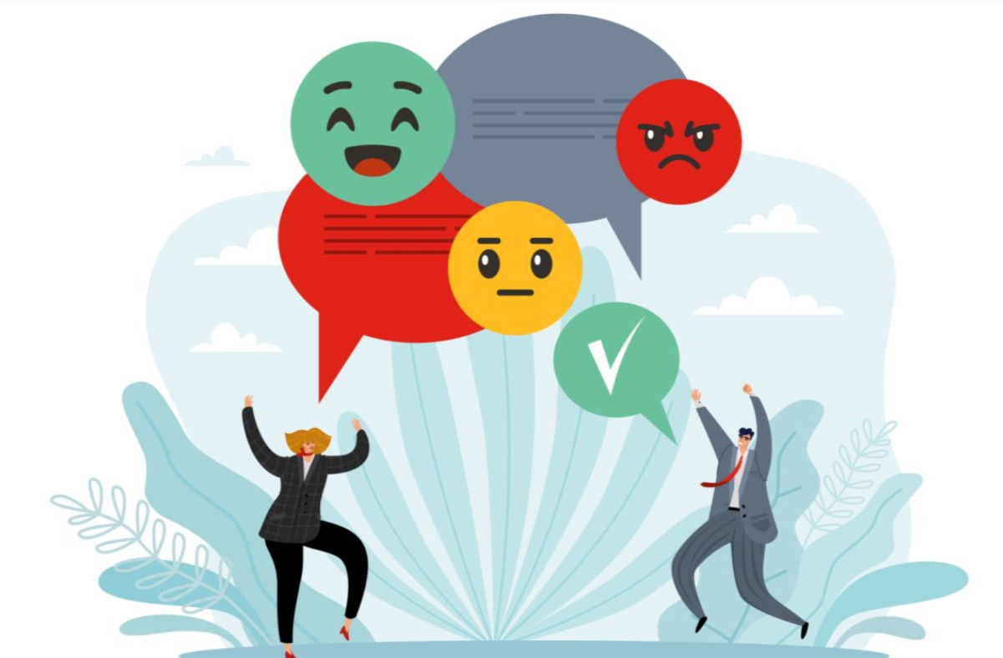

LIBRARIES USED:

**NLTK (Natural Language Toolkit):**

* NLTK is a popular Python library for natural language processing. It provides tools and resources for text preprocessing, tokenization, stemming, and sentiment analysis lexicons. NLTK is a great choice for educational and research purposes.

VADER (Valence Aware Dictionary and sentiment Reasoner):

* VADER is a sentiment analysis tool specifically designed for analyzing social media text. It assigns sentiment scores to text based on a pre-built sentiment lexicon and is useful for quick sentiment analysis tasks.

TextBlob:

* TextBlob is a simplified text processing library built on top of NLTK and Pattern. It offers a user-friendly API for tasks like part-of-speech tagging, sentiment analysis, and translation.

Pickle:

* Python module that provides a way to serialize (convert objects into a byte stream) and deserialize (recreate objects from a byte stream) Python objects.

Data Exploration:

Data exploration is a crucial step in the data analysis process. It involves gathering an initial understanding of your dataset, identifying patterns, and gaining insights to inform subsequent data analysis tasks.

Data exploration is an iterative process, and the insights gained from it inform subsequent data cleaning, feature engineering, and modeling steps. Effective data exploration is essential for making informed decisions, selecting appropriate analysis techniques, and ensuring the quality and integrity of your analysis results.

Data Preprocessing:

Data preprocessing for sentiment analysis involves several specific steps to prepare text data for analysis and modelling training.

* Text Cleaning
* Tokenization
* Stopward Removel

Feature Extraction:

Feature extraction in sentiment analysis involves converting text data into numerical features that machine learning models can understand and use for prediction. Text data is inherently unstructured, so feature extraction is a critical step in transforming it into a format suitable for sentiment analysis models

* In this project we used VADER ,Vader contains all algorithem that are suitable for the projects that we are doing.
* It is specifically tailored to handle the unique characteristics of text from platforms like Twitter, where language can be informal, and sentiment can be expressed using emoticons, slang, and other unconventional forms

Visualization:

Visualization plays a crucial role in sentiment analysis by providing insights into sentiment patterns and helping communicate the results of your analysis effectively.

1. **Histograms and Density Plots:**
   * Histograms and density plots can show the distribution of sentiment scores or sentiment intensity in the text data. They can reveal patterns of sentiment across the dataset.
2. **Time-Series Plots:**
   * In sentiment analysis of social media data or news articles, time-series plots can visualize sentiment trends over time. This helps track how sentiment changes in response to events or trends.
3. **Scatter Plots:**
   * Scatter plots can be used to visualize relationships between two sentiment-related variables. For example, you can create a scatter plot to show the relationship between sentiment intensity and text length.

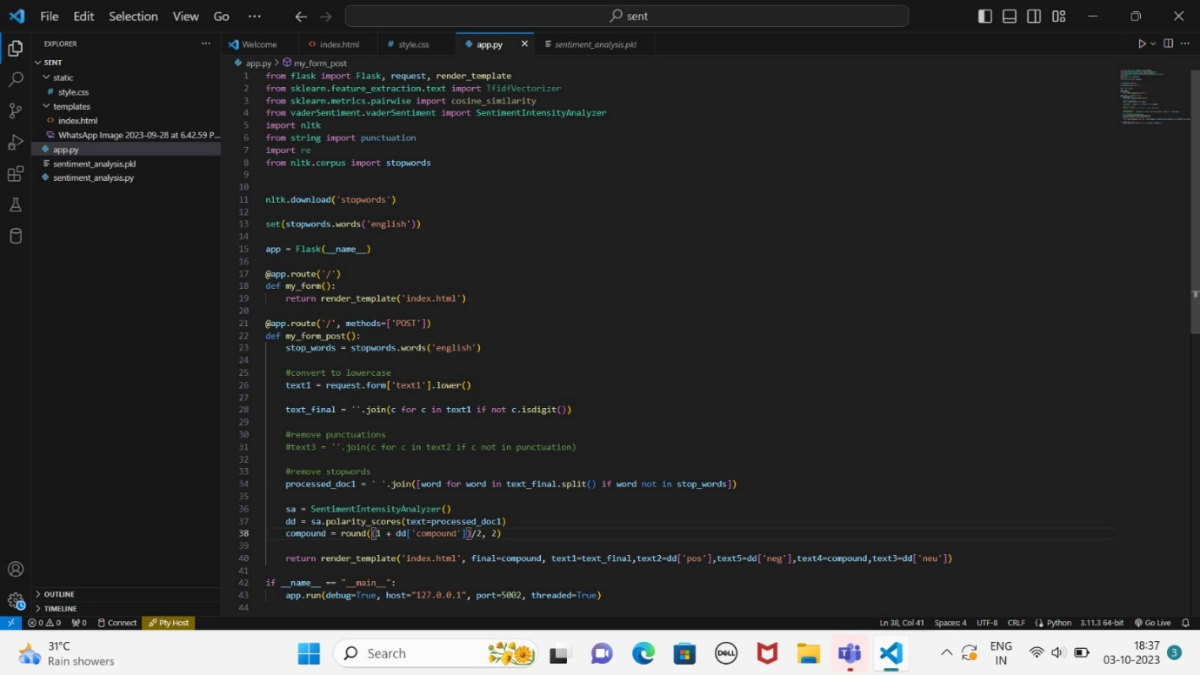

MODEL DEPLOYMENT:

Languages used: HTML,CSS

HTML:

HTML can play a role in sentiment analysis when you're dealing with text data that includes HTML tags or markup. In such cases, it's important to preprocess and clean the text data to remove HTML tags and extract the actual text content before performing sentiment analysis. Here's how HTML can be handled in sentiment analysis.

CSS:

CSS (Cascading Style Sheets) is primarily used for styling and formatting web content, and it is not directly related to sentiment analysis. However, when performing sentiment analysis on web data, such as user-generated content from websites or social media, you may encounter CSS-related issues that need to be considered during data preprocessing and analysis:

Deploying a sentiment analysis model involves making the trained model available for use in a production environment where it can analyze real-time or batch text data and provide sentiment predictions. Here's a general outline of the steps involved in deploying a sentiment analysis model:

1. **Model Serialization:**
   * Serialize (save) your trained sentiment analysis model to a file format that can be easily loaded in a production environment. Common serialization formats include Pickle for Python-based models and other formats like ONNX or TensorFlow's SavedModel for deep learning models.
2. **API Development (Optional):**
   * If you plan to deploy the model as a web service, develop an API (Application Programming Interface) that exposes endpoints for sending text data and receiving sentiment predictions.

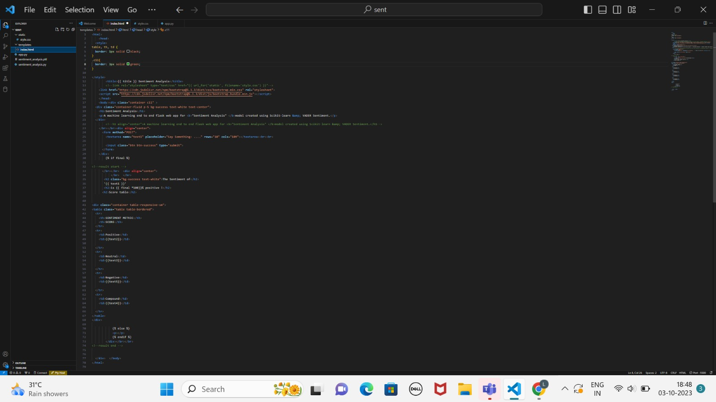

OUTPUT:

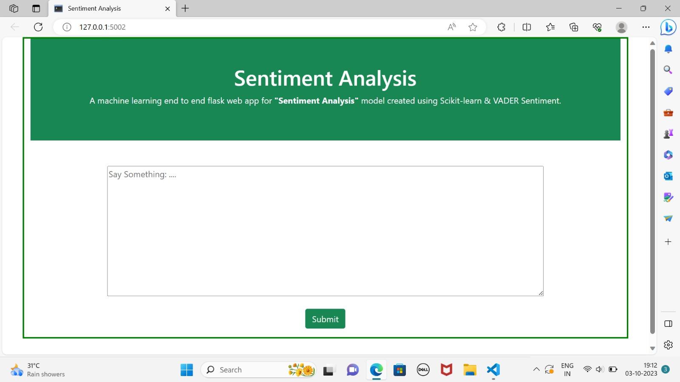

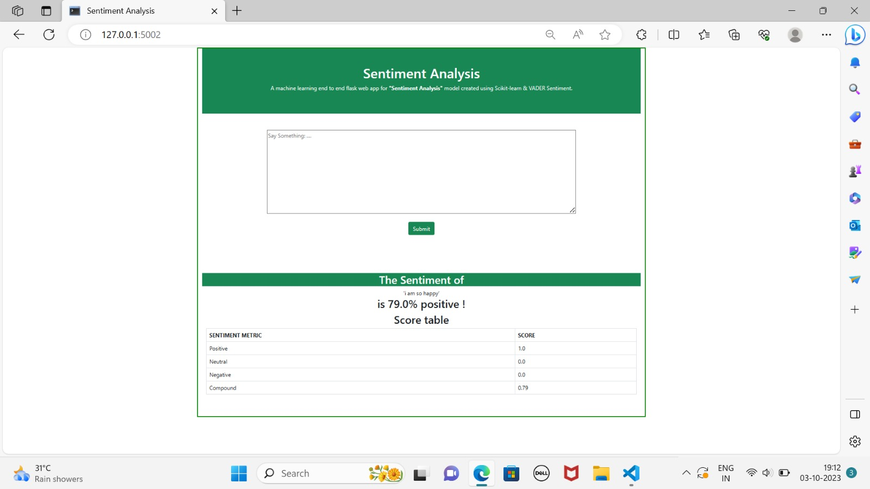

HERE WE NEED TO ENTER THE TEXT OR ANY STATEMENT

HERE WE GET % OF GIVEN STATEMENT

CONCLUSION:

A sentiment analysis project is a valuable endeavor that can provide valuable insights into public opinion, customer feedback, and user sentiment. Throughout the project, you have explored various aspects of sentiment analysis, from data collection to model development and deployment.

* Collect and prepared a relevant dataset for sentiment analysis, emphasizing data quality and representativeness.
* Data preprocessing was crucial to prepare the text data for analysis, involving cleaning, tokenization, stopword removal, and other steps.
* Feature extraction techniques were applied to convert text data into numerical features that machine learning models can use.
* You developed and trained sentiment analysis models, selecting the appropriate algorithm or architecture based on the project's goals and data characteristics.
* Models were evaluated and validated using appropriate metrics to ensure their effectiveness in capturing sentiment patterns accurately.
* Visualization techniques were used to communicate the results effectively, providing insights into sentiment patterns, trends, and distributions.
* The sentiment analysis model was deployed in a production environment, making it available for real-time analysis or batch processing.
* Documentation of the entire project, from data collection to deployment, was maintained for transparency, reproducibility, and future reference.
* Your sentiment analysis project has contributed to a better understanding of sentiment in the data source, with meaningful impacts on business decisions, social trend analysis, or other purposes.

Top of Form

Bottom of Form